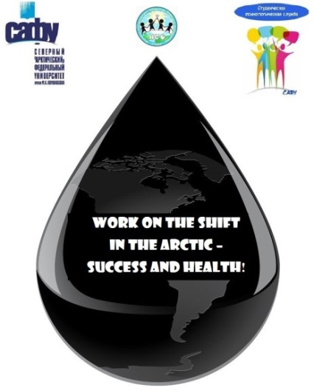
Northern (Arctic) Federal University
named after MV Lomonosov
Graduate School of Psychology, Pedagogy and Physical Education
Finnish Institute of Occupational Health
Arkhangelsk Branch of the Russian Psychological Society
Thematic network "Working in the Arctic" UArctic

Scientific Symposium "Work in the Arctic"

23-24 May 2019, Arkhangelsk

Northern Arctic Federal University (Arkhangelsk, North-West Russia) is pleased to announce the Scientific Symposium "Work in the Arctic" to be held as a side event of the Arctic Science Summit Week (ASSW) 2019 that will take place at the university in 23-24 May, 2019.
A scientific symposium devoted to the issues of psychology and physiology of labor in the Arctic, safety issues and maintaining an optimal functional state when working in walkable conditions, effects of group isolation conditions in the Arctic; effective technologies of labor support in the Arctic.

Participants:
- scientists in areas of oil and gas, geology and others who plan to work on a shift basis in the Arctic

Venue and dates
Arkhangelsk, Northern Arctic Federal University
23-24 May, 2019

Language of instruction
English

Financing
Participation fee is not provided.
Travel and accommodation is due to the directing side.
Travel
Arrival day: 23 May 2019
Departure day: 24 May 2019

To participate, you must fill out an application and send it of by email psps_wsash@bk.ru until 28 January 2019

Application for Scientific Symposium:

Should you have any questions, please do not hesitate to contact of by email psps_wsash@bk.ru.

Share your passion for the Arctic!

